4 Critical Steps for Biobanking on the Path to Precision Medicine
Precision medicine is upon us and it is more than the simple use of information to create drugs and diagnostics that are unique to a single patient. Precision Medicine identifies patients who are more susceptible to certain diseases, who will respond to treatments differently and whose diseases or conditions may progress on a different course than others in the general population.
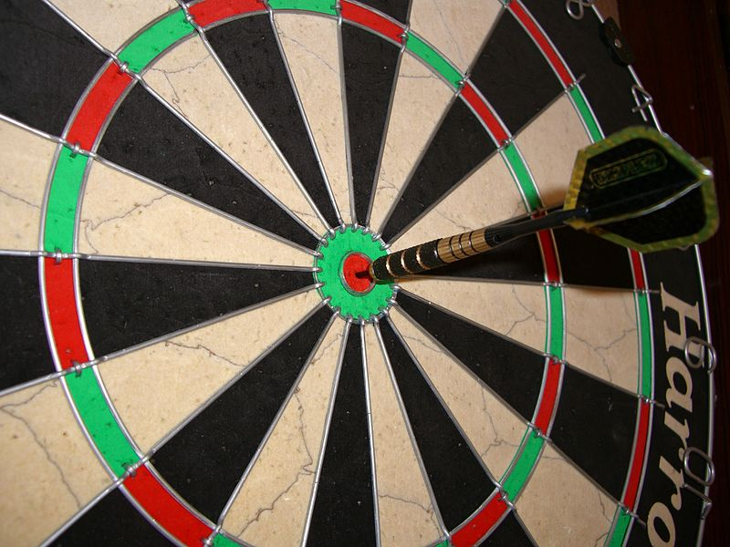
Testing for disease-causing mutations in the BRCA1 and BRCA2 genes, minimal residual disease (MRD) tests to quantify residual cancer which enable detection of tumor markers before physical signs and symptoms return,trastuzumab (marketed as Herceptin) used in the treatment of women with breast cancer in which the HER2 protein is overexpressed and tyrosine kinase inhibitors such as imatinib (marketed as Gleevec) developed to treat chronic myeloid leukemia (CML) – suggest the future that is Precision Medicine is upon us.

1. Be Ahead of the Curve and Get There Earlier!
The biospecimen is a cornerstone of Precision medicine. Attention to the development of basic documented processes and using technology solutions built to meet global privacy and security requirements will keep you ahead of the curve and get you there earlier! Proper sample inventory and tracking tools are a part of the critical path to Precision Medicine. As the cost of “omics” analysis continues to decrease, it is likely that third party insurers will pay that price to determine if pharmacological agents will or will not work on a particular person. Once third party payers recognize the value proposition, diagnosis and treatment decisions will become more dependent upon tissue analysis and the methods to collect, process, store and use biospecimens will receive increasing regulatory scrutiny.

2. Determine What Else You Need to do to Make Precision Medicine Successful?
In addition to the proper tracking and storage of biospecimens, samples require sufficient phenotypical data, control of chain of custody and access to, and control of, any constraints in any informed consent. Integration with, or data extraction from, clinical data management systems modified to collect a “standard panel” of biospecimen data along with any limitation in Informed consent while providing an audit trail for chain of custody should enable the generation of reports to verify biospecimens are used as intended with information that makes the sample valuable (and usable). Newer generation LIMS systems are built to be 21 CFR part 11 compliant have incorporated electronic data collection forms providing a single central source to collect the extended data required to make a biospecimen valuable.

3. Ask yourself, Should I In-Source or Out-Source?
Setting up and managing a Biobank that will meet regulatory compliance requirements is no simple task. In a cost analysis done with two major Biopharmaceutical companies, it cost $0.13 and $0.20 respectively, per aliquot, per month - just to store the sample. This does not include the cost (and effort) of sample logistics; more or less difficult depending upon the country in which you are working.
Will biospecimen management follow the CRO and/or EDC outsourcing model?
- The space required
- The cost and maintenance of freezers
- Installing and maintaining back-up electrical systems and disaster recovery procedures
- Global biospecimen logistical expertise
- And, audit-worthy Quality Management Systems (QMS)
Even with the cost premiums of outsourcing, the value proposition makes outsourcing a viable option to “growing your own” biobank.

4. Make Sample Acquisition Easier
Depending upon the source, it is estimated that there are about one billion biospecimens stored around the world. This boggles the mind because of the effort required to get targeted specimens for diagnostics or clinical research purposes. The most common approach is to perform a prospective targeted biospecimen clinical trial. Clearly this consumes time and is expensive. A number of biobanks have sample acquisition managers that spend their time networking with academic and commercial biospecimen providers, but this is a less than satisfactory model. And while there may be regulatory and even ethical issues to be sorted, why can’t we just go to an online “biospecimen market place” to sell, buy or exchange targeted samples?
This is more than just an idea as a few strong technology shops have introduced such “biospecimen exchange” technology solutions. It is just a matter of time before these systems provide sample acquisition alternatives.

Conclusion: From the Gray Zone
Biospecimen management will not survive in the regulatory grey zone! The Biopharmaceutical and Diagnostics industries need to start to “Cross the Chasm” to be prepared for the changing biospecimen management marketplace. What other steps do you think are critical in advancing biobanking towards Precision Medicine?

